Name : Fariha Arai

AF ID : AF0443236

Lab 7

**1. Print the first 10 natural numbers using for loop**

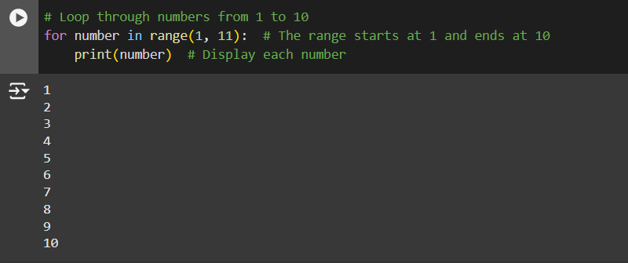

**2. Python program to check if the given string is a palindrome**

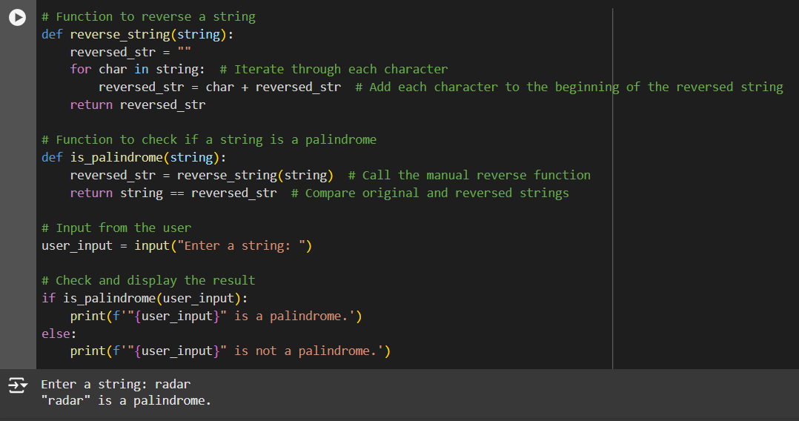

**3. Python program to check if a given number is an Armstrong number**

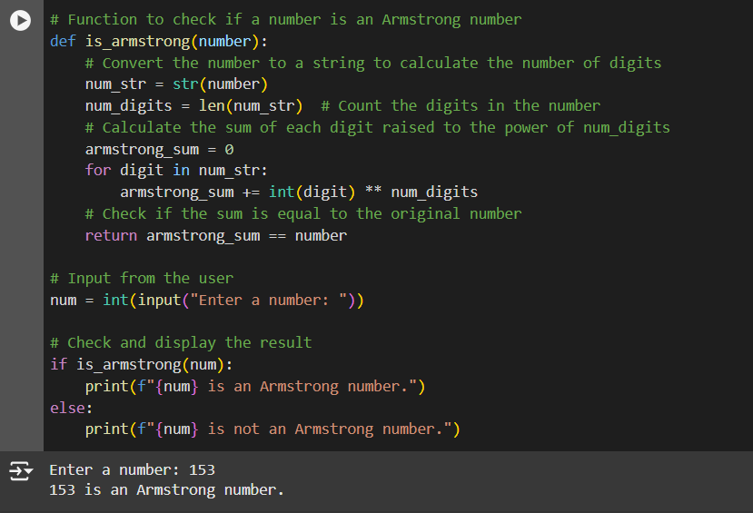

**4. Python program to get the Fibonacci series between 0 to 50**

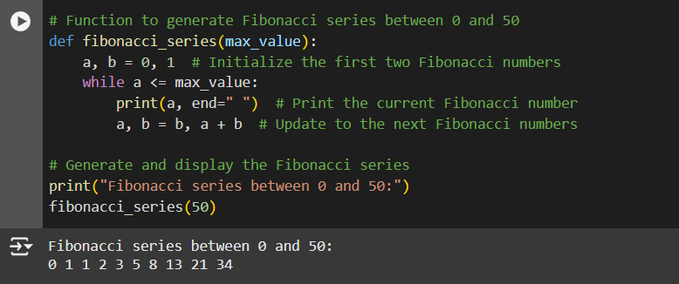

**5. Python program to check the validity of password input by users**

